4th Grade Math
Standard | 3.0 Items
4.2B represent the value of the digit in whole numbers through 1,000,000,000 and decimals to the hundredths using expanded notation and numerals | 4.2B/3.0 Option 1:  Student 1: 56 thousands + 17 tens + 83 tenths  Student 2: 50,000 + 6,000 + 100 + 70 + 0.80 + 0.03  Student 3: 50 ten thousands + 6 thousands + 1 ten + 7 ones + 0.8 + 0.03  Three students wrote the number 56,017.83. Which students wrote correct answers?  A All three students were correct.  B Only Student 3 was correct.  C Both Student 1 and Student 2 were correct.  D None of the students were correct.  4.2B/3.0 Option 2:  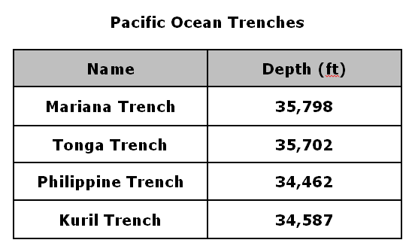  Which ocean trench contains a 3 with a value of 30,000, a 7 with a value of 7 hundreds, and zero tens?
 | 2.0 Items
- Write 547,238 in expanded notation.

2. Write (3 x 100,000) + (5 x 10,000) + (2 x 10) + (9 x 1) in standard form.

3. Which number represents 300 + 40 + 3 + 0.05
- 304.05
- 340.50
- 343.5
- 343.05

4. Which number represents
(8 x 10,000) + (1 x 10,000) + (3 x 100) + (5 x 1) + (3 x 0.1)

- 8135.3
- 81,305.3
- 81,350.3
- 81,305.03

5. A student represented 427.19 incorrectly.

6. Circle the students mistakes and represent the number correctly.

- 400 + 20 + 7 + 0.01 + 0.09

b. (4 x 100) + (2 x 10) + (1 x 0.1) + (9 x 0.1)

7. Compare the values of each 5 in the number 552,298. Use a picture, numbers, or words to explain.

8. Round 139,999 to the nearest hundred thousands place.

Use the table below to answer the questions.

Baseball Game Attendance
Game | Number of People
1 | 45,753
2 | 42,250
3 | 43,160
4 | 41,779

9. Record the attendance for Game 2. Explain how the value of the 2 in the thousands place compares to the value of the 2 in the hundreds place.

10. Round the Game 4 attendance to the nearest thousand.

11. Which correctly shows the numbers in order from least to greatest?
- 45,753; 43,160; 42,250; 41,779
- 42,250; 43,160; 41,779; 45,753
- 41,779; 42,250; 43,160; 45,753
- 43,160; 45,753; 41,779, 42,250

12. Compare using >, <, or =. Write your answer inside the circle.

- 234 thousands + 7 ten thousands (circle) 241,000
- 4 hundred thousands – 2 thousands (circle) 200,000

13. Compare using >, <, or =. Write your answer inside the circle.
- (insert picture of 4.03) (insert circle picture) (insert picture of 4.30)
- (insert picture of 2.81) (insert circle picture) (insert picture of 2.18)

Standard | 3.0 Items
4.4A add and subtract whole numbers and decimals to the hundredths place using the standard algorithm | 4.4A/3.0  - Find the sum of the following numbers: 145,936 + 610,348 using standard algorithm.  B. Find the difference between the following numbers: 713,046 - 552,163 using the standard algorithm.
 | 2.0 Items
- Find the sum of the following numbers: 34,923 + 302,994 using standard algorithm.

2. Find the difference between the following numbers: 201,361 - 51,047 using the standard algorithm.

3. Select a strategy or tool to determine the answer for the following numbers: 2,504 + 1,462

4. Select a strategy or tool to determine the answer for the following numbers: 5,227 - 3,904 using the standard algorithm.

5. Write a new expression using compatible numbers for the following problems:

- 523 + 602

- 922 + 374

- 793 - 241

- 1,015 - 335

Standard | 3.0 Items
4.5A represent multi-step problems involving the four operations with whole numbers using strip diagrams and equations with a letter standing for the unknown quantity | 4.5A/3.0:  Option 1:  - Write an equation for d to represent the situation shown in the strip diagram below.  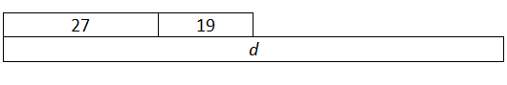  - Draw a strip diagram to represent the following equation:  345 + 127 + p = 771.  Option 2:  - Write an equation for y to represent the situation shown in the strip diagram below.  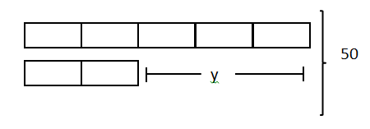  - Draw a strip diagram to represent the following equation:  35 x 4 ➗ .2.
 | 2.0 Items
- Write an equation for the strip diagram.

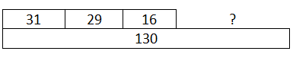
Write an equation for r to represent the situation shown in the strip diagram below.

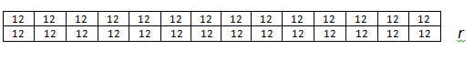

2. Write an equation for j to represent the situation shown in the strip diagram below.
.
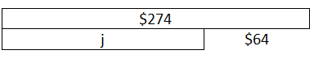

3. Draw a strip diagram to represent this equation.
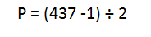
4. Draw a strip diagram to represent this equation.

s = (2 x 6) – 4

5. Write a multiplication and a division number sentence to best represent this array.

6. Represent 13 x13 with an array.

7. Represent 38 x 14 with an area model.

8. Write the equation for this area model.
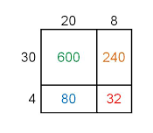
9. Draw an array or area model to represent 96 ÷ 8.

10. Draw an area model to represent 225 ÷ 5.

11. Which strip diagram correctly represents the following equation?
(110 - 30) ÷ 4
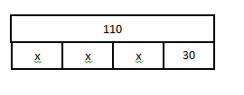

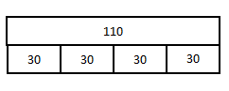
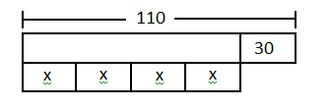
Standard | 3.0 Items
4.5B represent problems using an input-output table and numerical expressions to generate a number pattern that follows a given rule representing the relationship of the values in the resulting sequence and their position in the sequence | 4.5B/3.0  Use the information from the equation below to answer A-C.  Jamal’s age - 9 = Madison’s age  - Which input-output table matches Jamal’s rule?  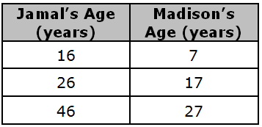  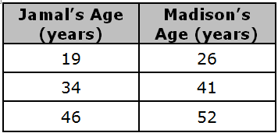  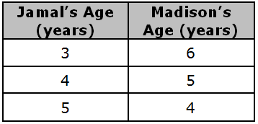  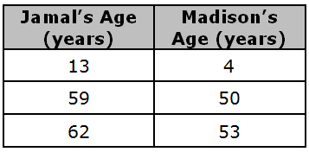  B. If Jamal is 54 years old, how old will Madison be?  C. Write a new expression to show the relationship Madison’s age in relation to Jamal’s age?  D. Use the input-output machine to complete the number pattern for the first five numbers in a sequence..  Input  Output  x 3  ______, ______, ______, ______, ______
 | 2.0 Items
- The rule for the table below is
position number times five equals the sequence. Complete the table below to show the process and values in this sequence.
(can be reworded if needed).

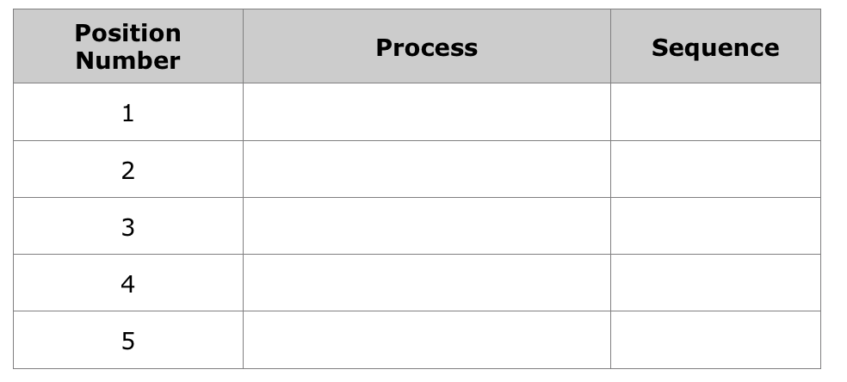

2. Look at the following table.
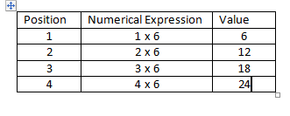
3. Write a numerical pattern to match the rule in the table.

4. What numerical expression would you use to find the value of the 16th position?

8
8
Complete the table with the following rule:
Output - 8 = Input

Input | Output
5 | 13
6
 | 15
 | 20
15

